Chapter 8 Problems, Part 2

35. Modify the MODEL table to add the attribute and insert the values shown in the following table.

ALTER TABLE MODEL

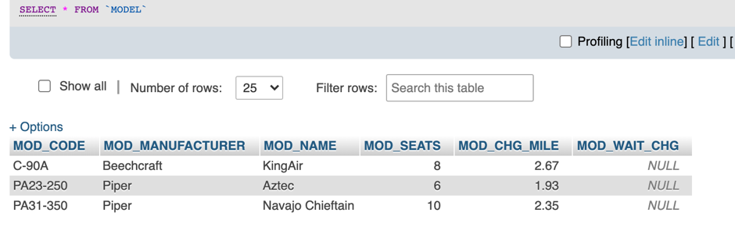ADD MOD_WAIT_CHG NUMERIC(5,2);

1. Write the queries to update the MOD_WAIT_CHG attribute values based on Problem 35.

UPDATE MODEL

SET MOD_WAIT_CHG = 100

WHERE MOD_CODE = 'C-90A';

UPDATE MODEL

SET MOD_WAIT_CHG = 50

WHERE MOD_CODE = 'PA23-250';

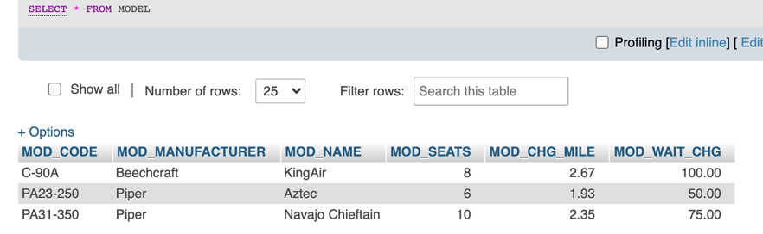UPDATE MODEL

SET MOD_WAIT_CHG = 75

WHERE MOD_CODE = 'PA31-350';

1. Modify the CHARTER table to add the attributes shown in the following table.

ALTER TABLE CHARTER

ADD CHAR_WAIT_CHG NUMERIC,

ADD CHAR_FLT_CHG_HR NUMERIC,

ADD CHAR_FLT_CHG NUMERIC,

ADD CHAR_TAX_CHG NUMERIC,

ADD CHAR_TOT_CHG NUMERIC,

ADD CHAR_PAYMENT NUMERIC,

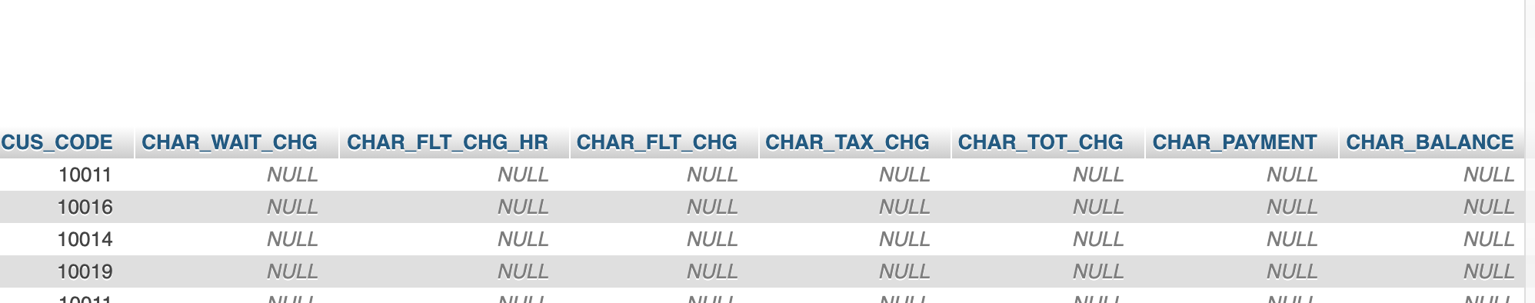ADD CHAR_BALANCE NUMERIC;

1. Write the sequence of commands required to update the CHAR_WAIT_CHG attribute values in the CHARTER table. (*Hint*: Use either an updatable view or a stored procedure.)

UPDATE CHARTER

SET CHAR_WAIT_CHG = (

SELECT MOD_WAIT_CHG FROM MODEL, AIRCRAFT

WHERE MODEL.MOD_CODE = AIRCRAFT.MOD_CODE AND AIRCRAFT.AC_NUMBER = CHARTER.AC_NUMBER

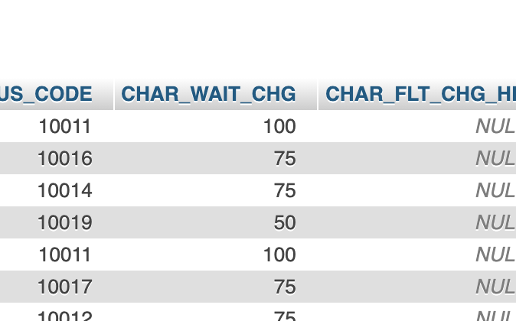 );

1. Write the sequence of commands required to update the CHAR_FLT_CHG_HR attribute values in the CHARTER table. (*Hint*: Use either an updatable view or a stored procedure.)

UPDATE CHARTER

SET CHAR_FLT_CHG_HR = (

SELECT MOD_CHG_MILE FROM MODEL, AIRCRAFT

WHERE MODEL.MOD_CODE = AIRCRAFT.MOD_CODE AND AIRCRAFT.AC_NUMBER = CHARTER.AC_NUMBER

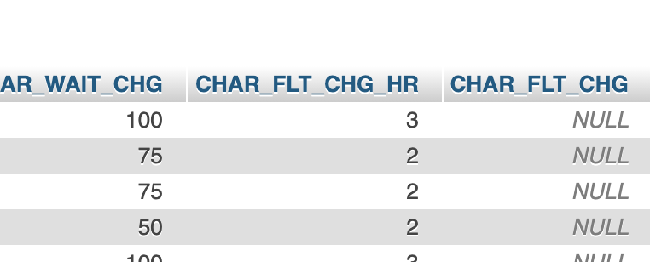 );

1. Write the command required to update the CHAR_FLT_CHG attribute values in the CHARTER table.

UPDATE CHARTER

SET CHAR_FLT_CHG = CHAR_HOURS_FLOWN * CHAR_FLT_CHG_HR;

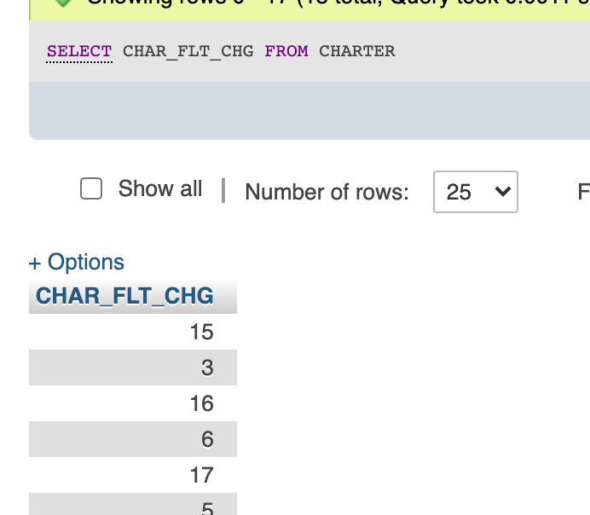

1. Write the command required to update the CHAR_TAX_CHG attribute values in the CHARTER table.

UPDATE CHARTER

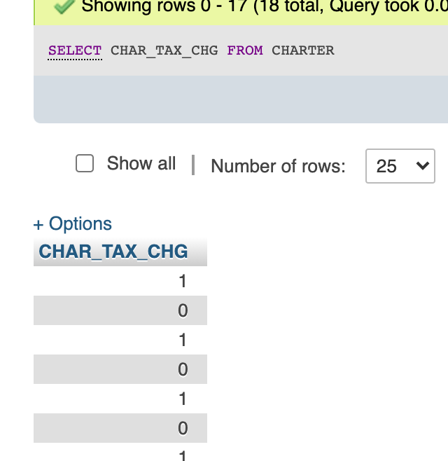SET CHAR_TAX_CHG = CHAR_FLT_CHG * .08;

1. Write the command required to update the CHAR_TOT_CHG attribute values in the CHARTER table.

UPDATE CHARTER

SET CHAR_TOT_CHG = CHAR_FLT_CHG + CHAR_TAX_CHG;

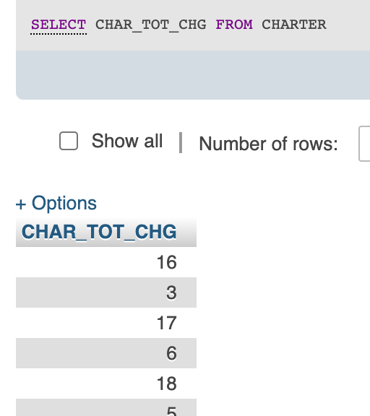

1. Modify the PILOT table to add the attribute shown in the following table.

ALTER TABLE PILOT

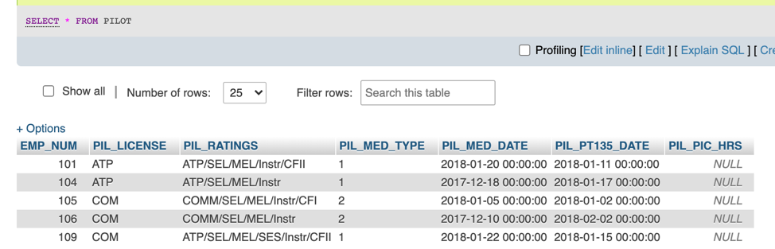ADD PIL_PIC_HRS NUMERIC;

**LEETCODE PORTION**

X city opened a new cinema, many people would like to go to this cinema. The cinema also gives out a poster indicating the movies’ ratings and descriptions.

Please write a SQL query to output movies with an odd numbered ID and a description that is not 'boring'. Order the result by rating.

SELECT ID, MOVIE, DESCRIPTION, RATING

FROM CINEMA

WHERE (ID%2 != 0) AND (DESCRIPTION != 'BORING')

ORDER BY RATING DESC;

Given the Employee table, write a SQL query that finds out employees who earn more than their managers. For the above table, Joe is the only employee who earns more than his manager.

SELECT EMP.Name as "Employee"

FROM EMPLOYEE as EMP,

EMPLOYEE as MANG

WHERE EMP.ManagerID = MANG.ID AND EMP.SALARY > MANG.SALARY;

Suppose that a website contains two tables, the Customers table and the Orders table. Write a SQL query to find all customers who never order anything.

SELECT CUSTOMERS.NAME AS 'CUSTOMERS'

FROM CUSTOMERS

WHERE CUSTOMERS.ID NOT IN

(

SELECT CUSTOMERID FROM ORDERS

);

Write a SQL query to find employees who have the highest salary in each of the departments. For the above tables, your SQL query should return the following rows (order of rows does not matter).

SELECT DEPARTMENT.NAME AS 'DEPARTMENT', EMPLOYEE.NAME AS 'EMPLOYEE', SALARY

FROM EMPLOYEE JOIN DEPARTMENT ON EMPLOYEE.DEPARTMENTID = DEPARTMENT.ID

WHERE (EMPLOYEE.DEPARTMENTID, SALARY)

IN (

SELECT DEPARTMENTID, MAX(SALARY)

FROM EMPLOYEE

GROUP BY DEPARTMENTID

);

Write a SQL query to find all numbers that appear at least three times consecutively.

SELECT DISTINCT log1.Num AS 'CONSECNUM'

FROM LOGS LOG1, LOGS LOG2, LOGS LOG3

WHERE LOG1.ID = LOG2.ID-1 AND LOG2.ID = LOG3.ID-1 AND LOG1.NUM = LOG2.NUM AND LOG2.NUM = LOG3.NUM;